**Weather Data Live Streaming**

**Step 1:** Zookeeper:

*~ cd /Volumes/Ext_ssd/kafka_2.13-3.7.1  
~ cd bin  
~ ./zookeeper-server-start.sh ../config/zookeeper.properties*  
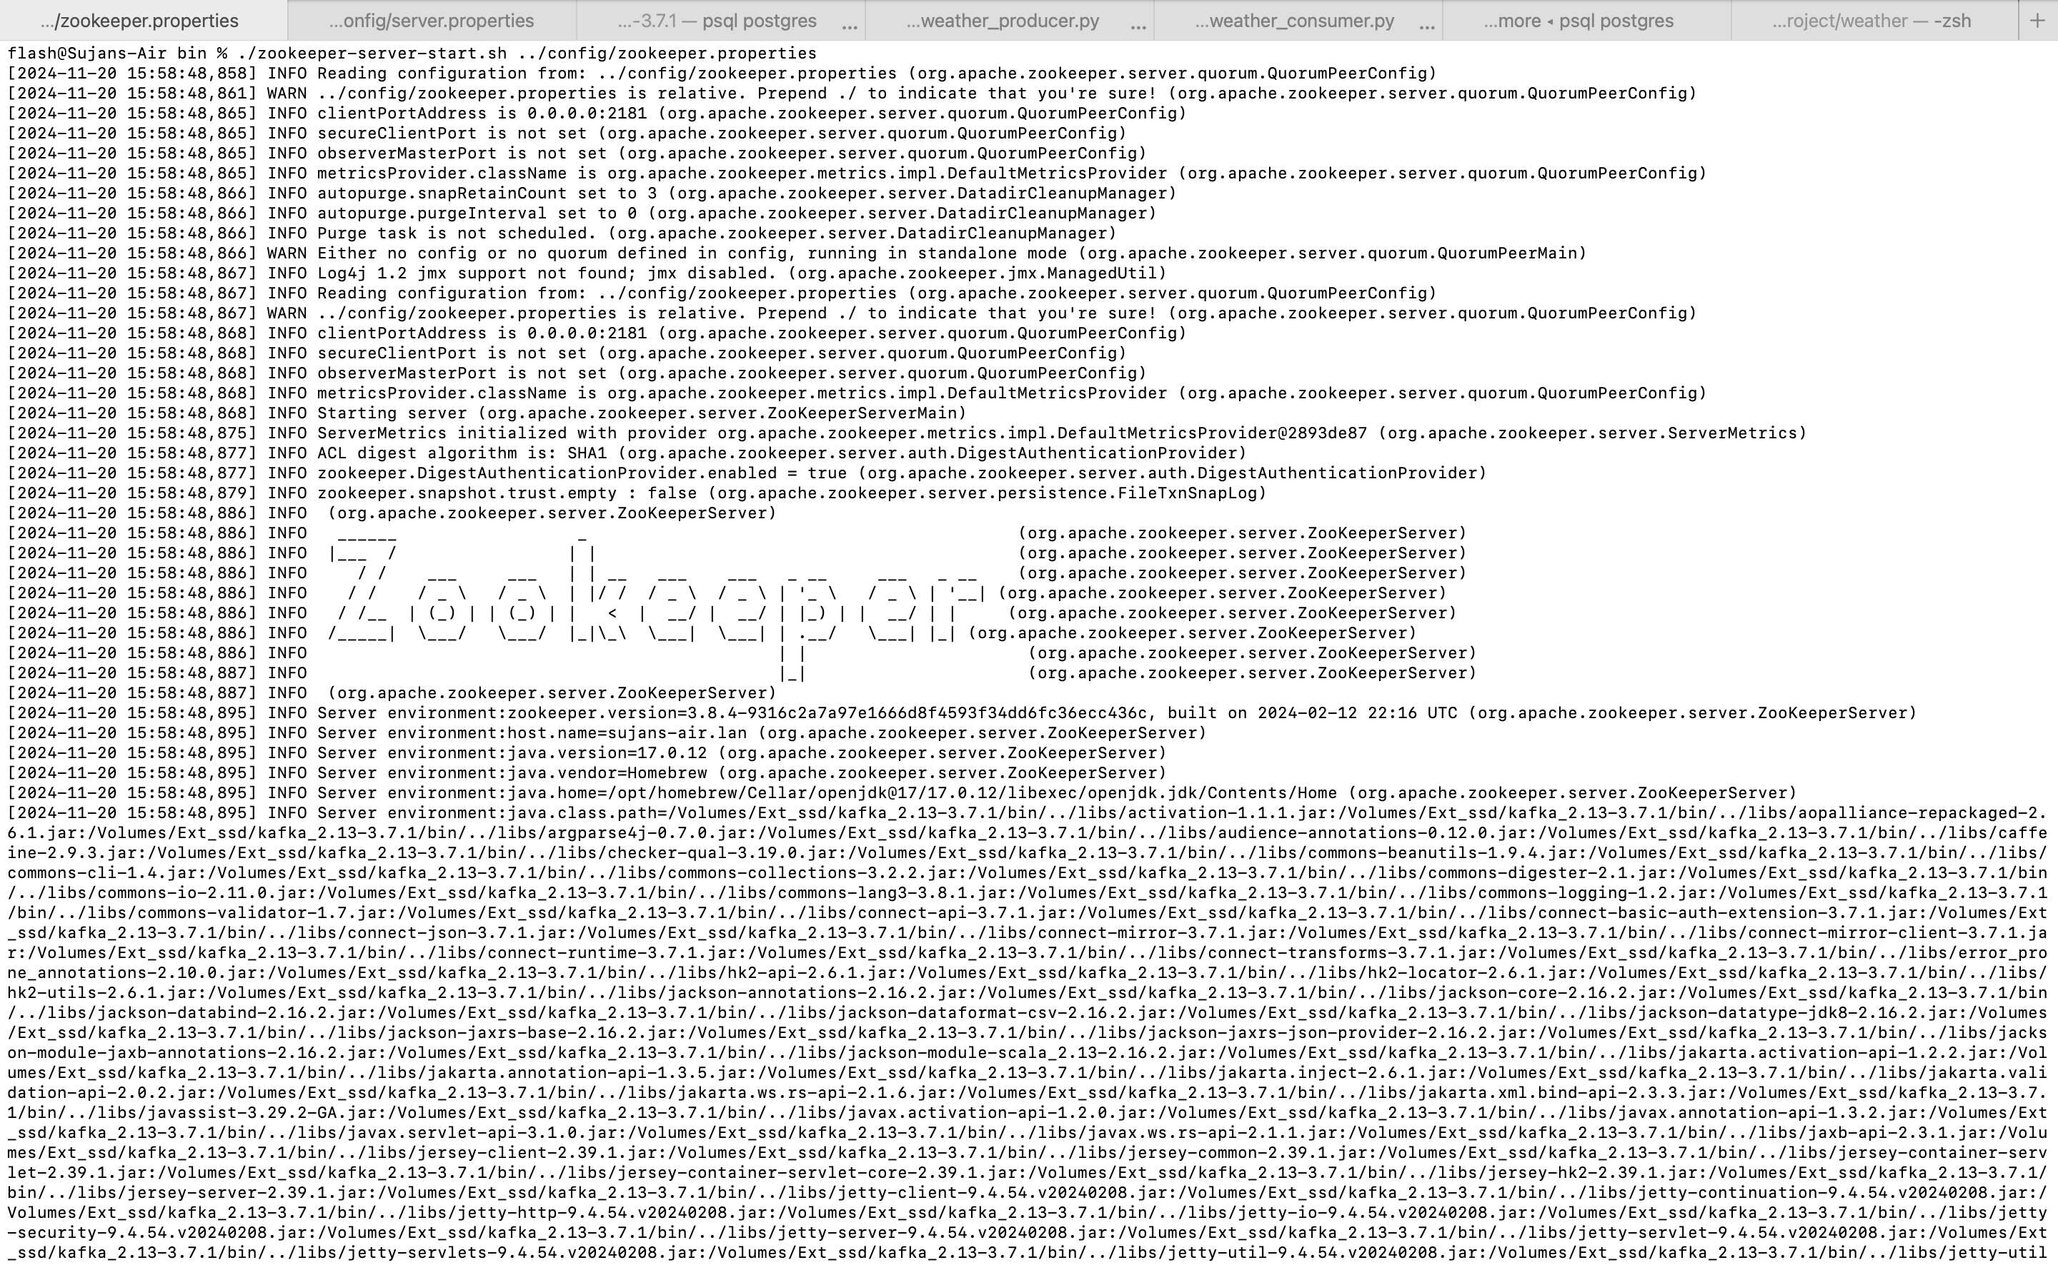

**Step 2:** Kafka server starting process:  
  
While zookeeper is running open another terminal and start the kafka server so that it can connect  
  
*~cd /Volumes/Ext_ssd/kafka_2.13-3.7.1*

*cd bin*

*~ ./kafka-server-start.sh ../config/server.properties*

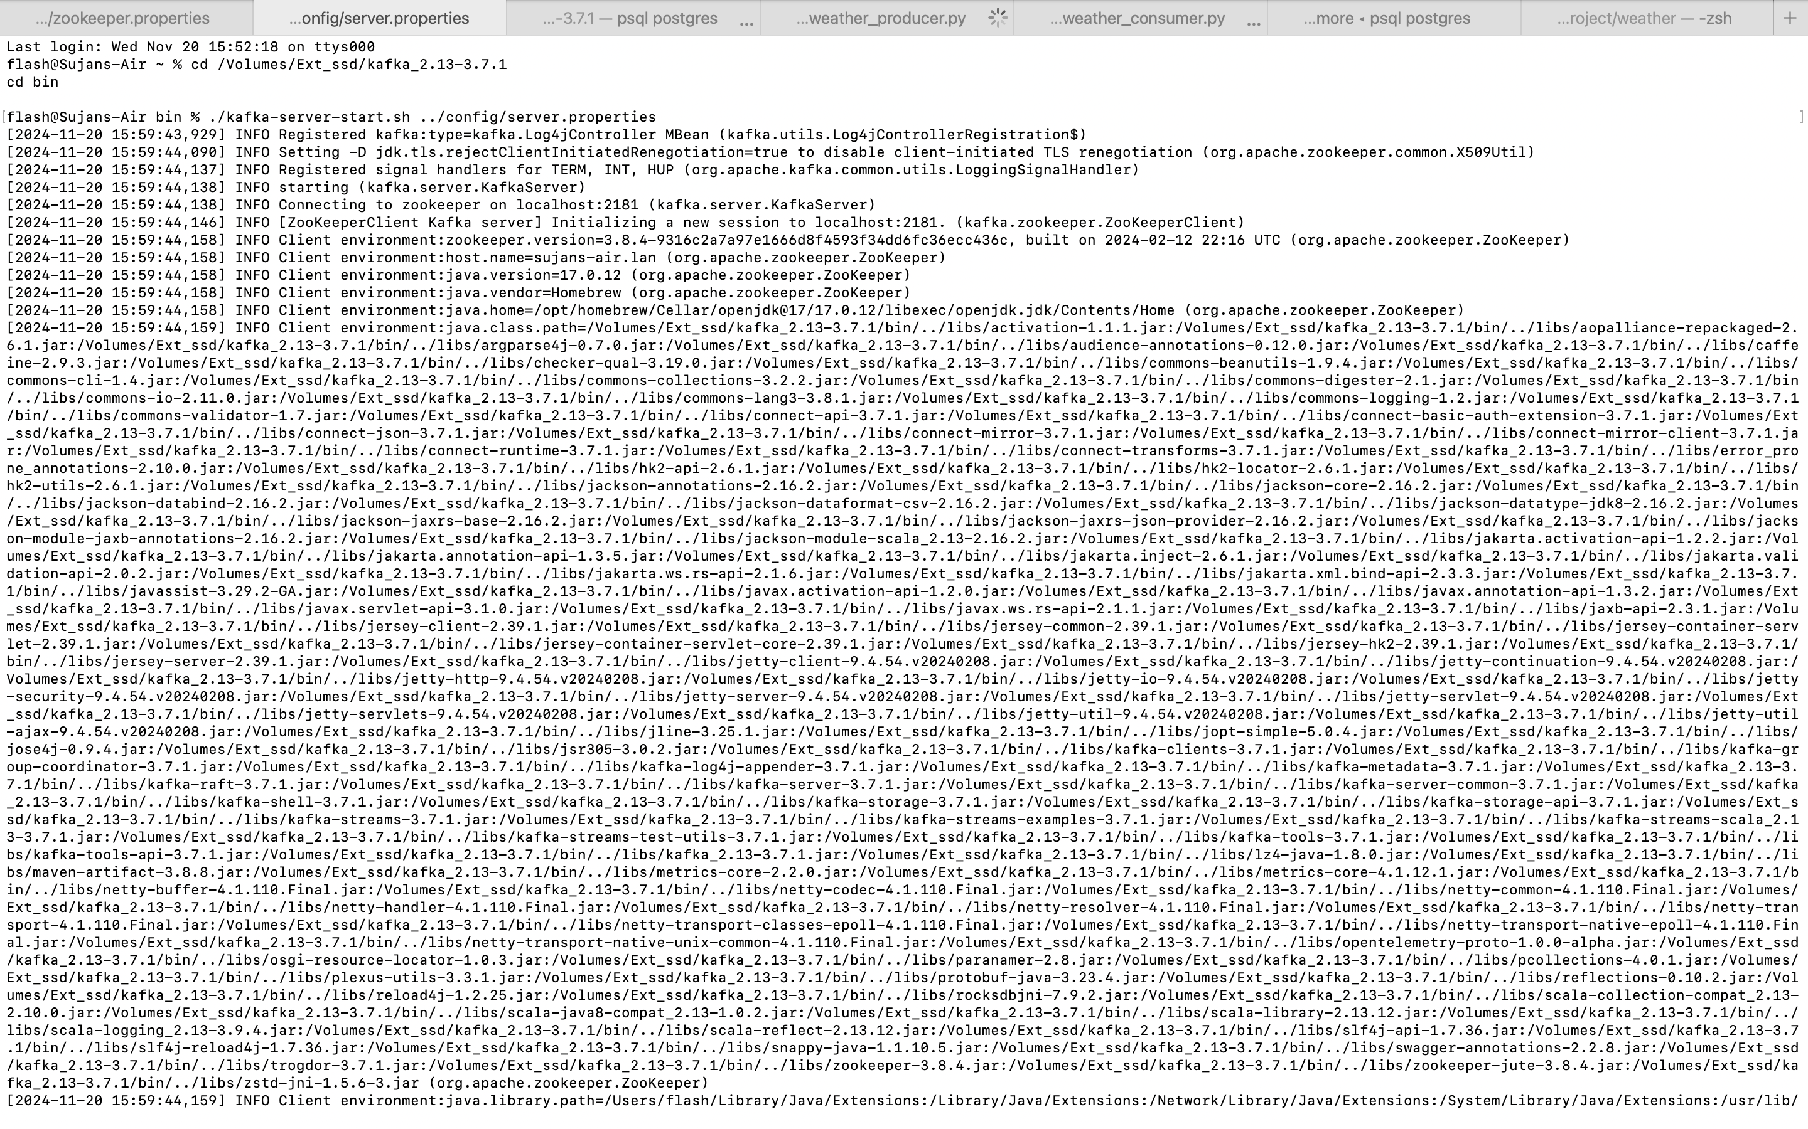

**Step 3:** Kafka Producer:

After installing all the required packages in python3 we can start with producer.  
  
My Producer code:  
from kafka import KafkaProducer

import requests

import json

import time

# Kafka Producer setup

producer = KafkaProducer(

bootstrap_servers='localhost:9092',

value_serializer=lambda v: json.dumps(v).encode('utf-8')

)

# OpenWeather API setup

API_KEY = "d4d7fa7699980bd4c97172d9287f6024" # Replace with your API key

CITY = "Dallas"

URL = f"http://api.openweathermap.org/data/2.5/weather?q={CITY}&appid={API_KEY}"

while True:

try:

# Fetch weather data

response = requests.get(URL)

weather_data = response.json()

# Send data to Kafka

producer.send('weather_data', weather_data)

print(f"Produced: {weather_data}")

# Wait for 10 seconds before fetching again

time.sleep(10)

except Exception as e:

print(f"Error: {e}")

response = requests.get(URL)

weather_data = response.json()

print(f"Fetched Data: {weather_data}")

*~ /opt/homebrew/bin/python3.10 weather_producer.py*

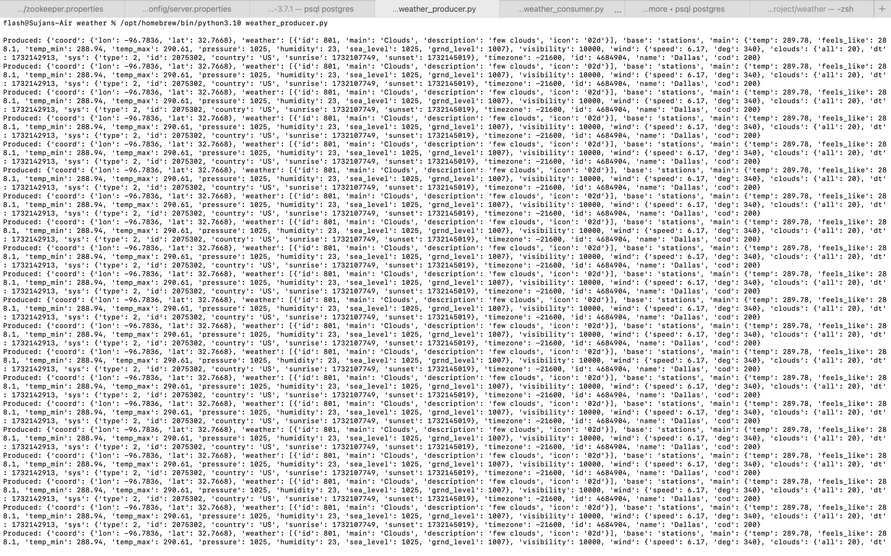

After starting producer open another window to start a consumer to read messages sent by the retrieved data.

**Step 4:** Kafka Consumer:

creating a new kafka environment so that everything happens in that system

*~/opt/homebrew/bin/python3.10 -m venv kafka_env*

*~ source kafka_env/bin/activate*

Installing additional packages:

kafka-python 2.0.2

pip 24.3.1

psycopg2-binary 2.9.10

My consumer code:

from kafka import KafkaConsumer

import psycopg2

import json

from datetime import datetime

# PostgreSQL connection setup

try:

conn = psycopg2.connect(

host="localhost", # PostgreSQL server address

database="weather_data_db", # Name of your database

user="flash", # Replace with your PostgreSQL username

password="1045" # Replace with your PostgreSQL password

)

cursor = conn.cursor()

print("Connected to PostgreSQL successfully!")

except Exception as e:

print(f"Error connecting to PostgreSQL: {e}")

exit(1)

# Kafka Consumer setup

try:

consumer = KafkaConsumer(

'weather_data', # Kafka topic name

bootstrap_servers='localhost:9092',

auto_offset_reset='earliest',

value_deserializer=lambda x: json.loads(x.decode('utf-8'))

)

print("Connected to Kafka successfully!")

except Exception as e:

print(f"Error connecting to Kafka: {e}")

exit(1)

print("Consumer started. Writing data to PostgreSQL...")

# Consume messages from Kafka and write to PostgreSQL

for message in consumer:

try:

# Parse the consumed message

data = message.value

city = data['name']

temperature = data['main']['temp']

humidity = data['main']['humidity']

timestamp = datetime.utcfromtimestamp(data['dt']) # Convert UNIX timestamp to datetime

# Insert data into PostgreSQL

cursor.execute("""

INSERT INTO weather_data (city, temperature, humidity, timestamp)

VALUES (%s, %s, %s, %s)

""", (city, temperature, humidity, timestamp))

conn.commit()

print(f"Inserted into database: {data}")

except Exception as e:

print(f"Error processing message: {e}")

conn.rollback()

producer.send('weather_data', weather_data)

print(f"Sent to Kafka: {weather_data}")

# Close the PostgreSQL connection gracefully

cursor.close()

conn.close()

The consumer started receiving messages and this has been connected to Postgres to store it in a Database to make a data visualization.

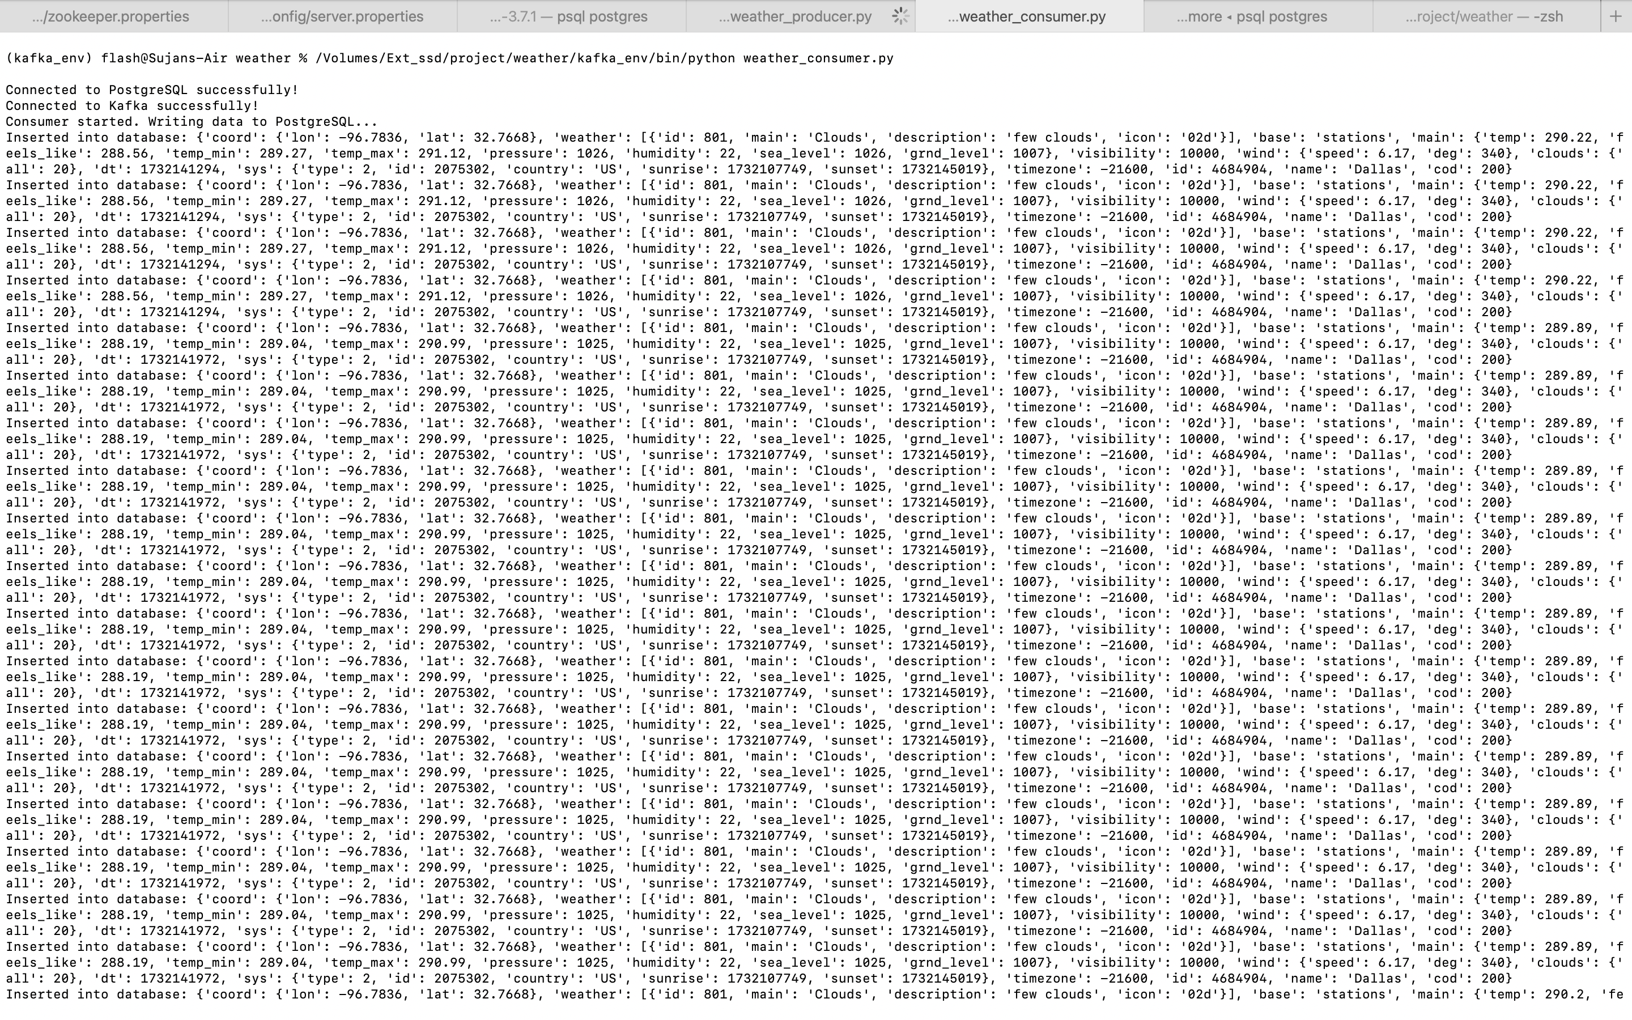

**Step 5:** PostGres:

I Have created a Database Weather_data_db and created a table to store all the retrieved data.

Then I connect the postgres to weather_data_db.

You are now connected to database "weather_data_db" as user "flash".

Verified whether data is storing?

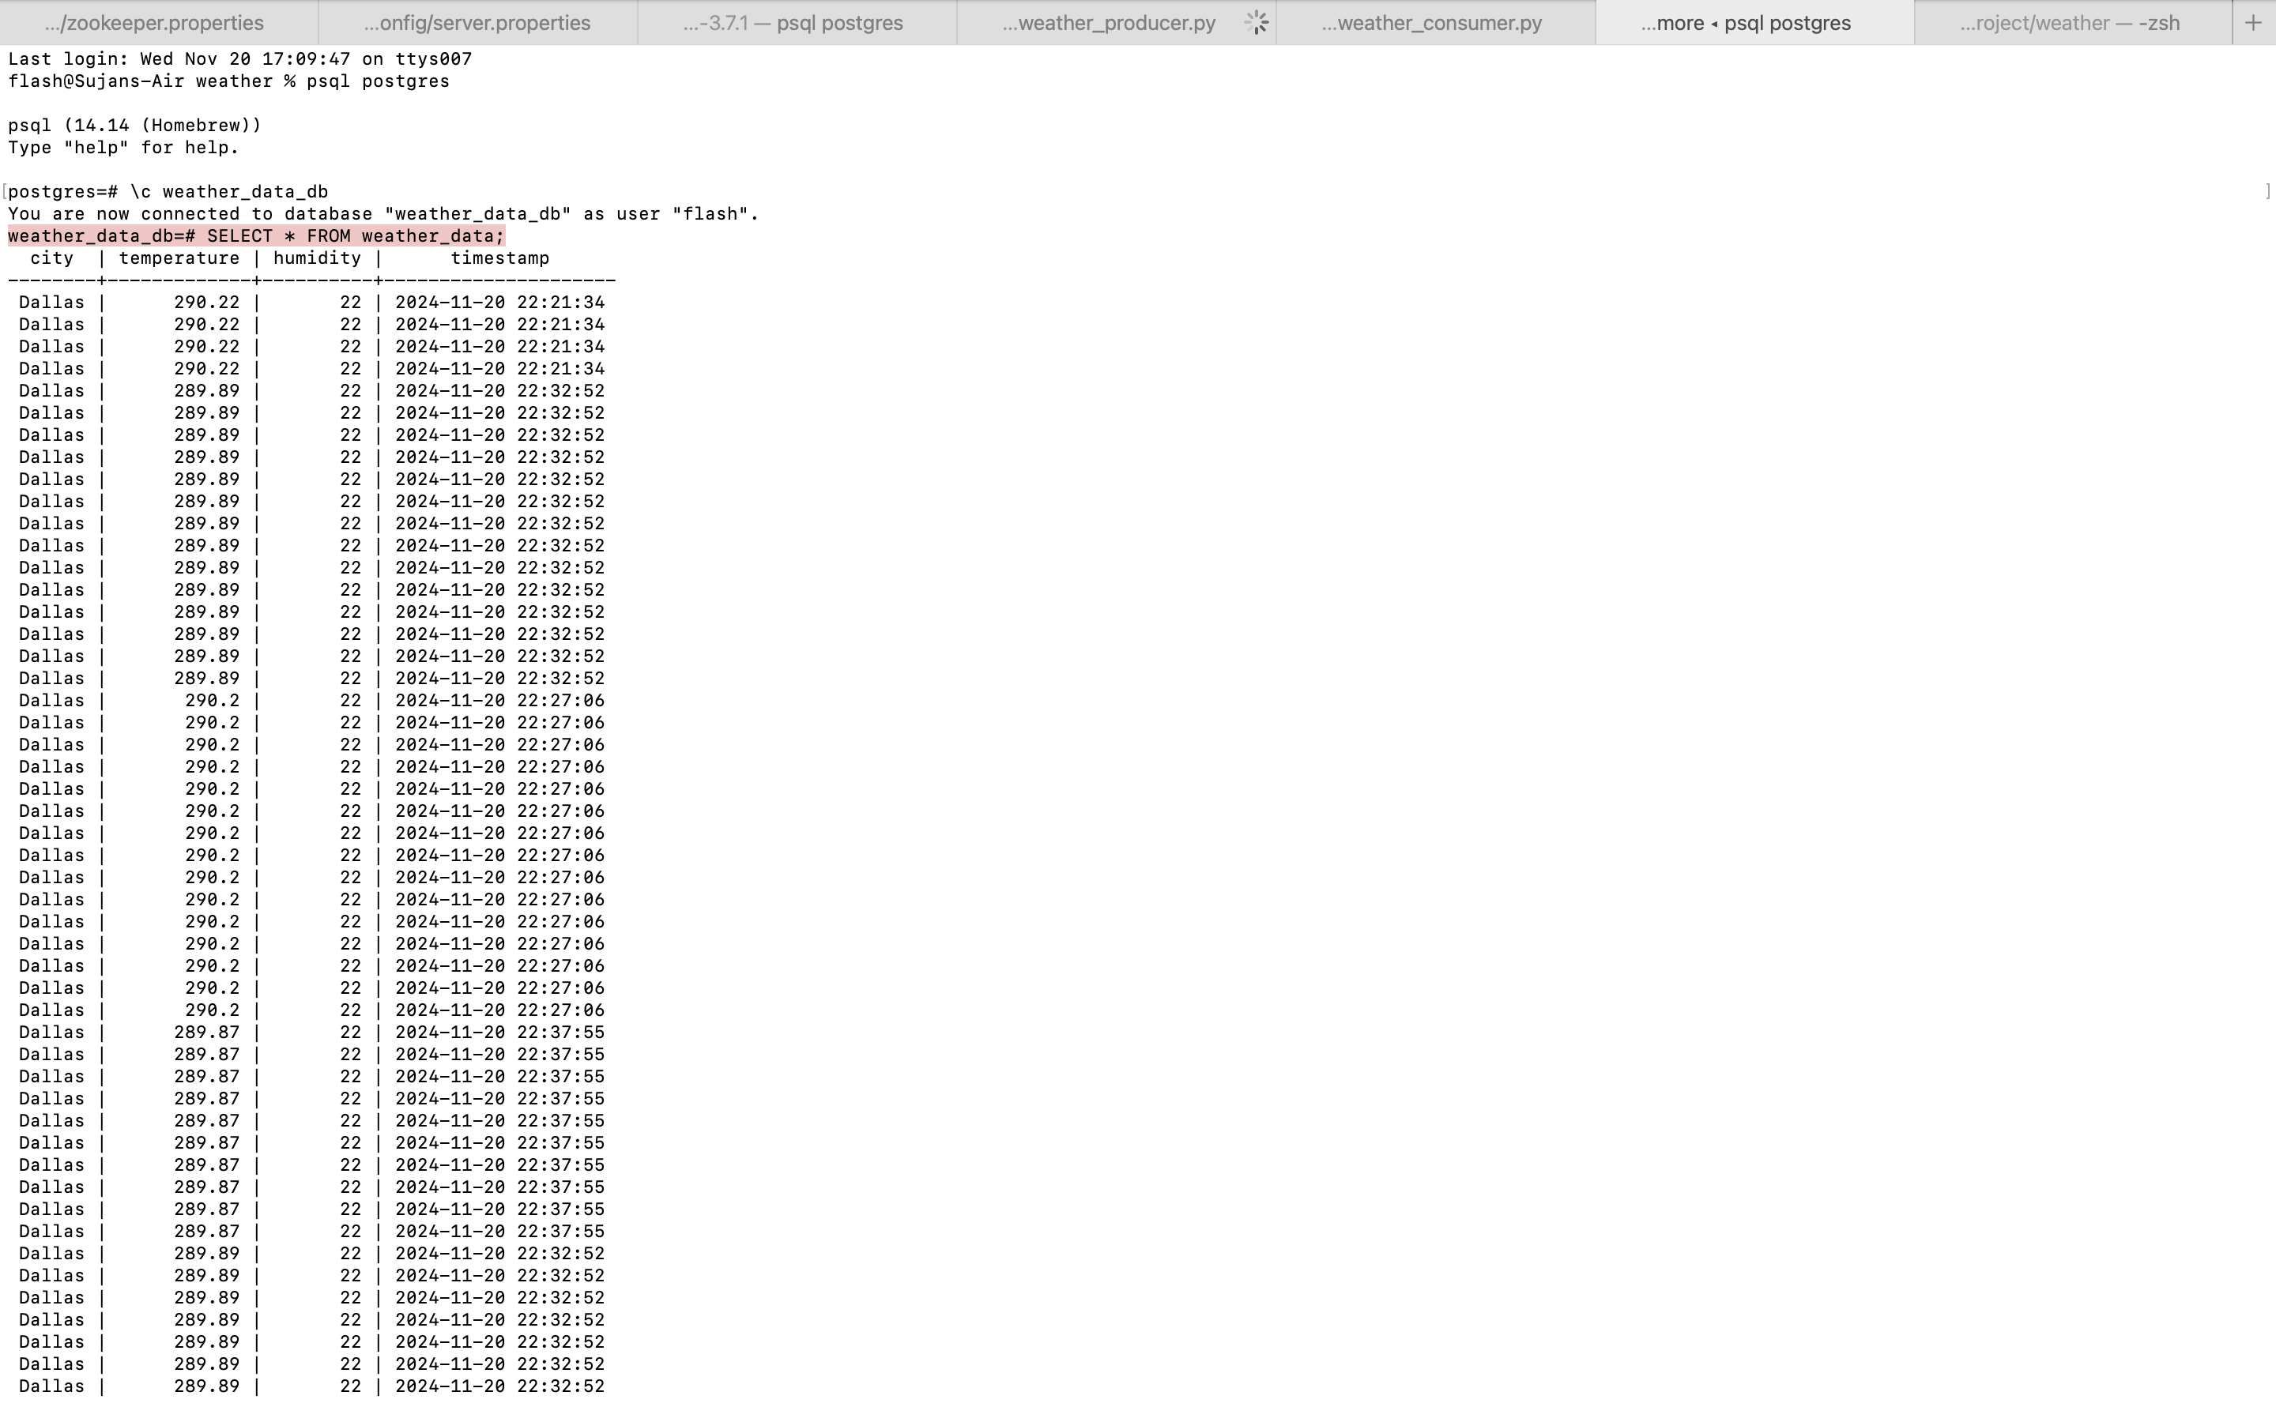

**Step 6:** Data Visualization

I have used Tableau to visualize.

Connect Tableau with weather_data_db PostGres server.

Then with appropriate mapping method I have graphed it and connected so that when the Data is retrieved it will be stored in PostGres server so that it will automatically get updated and give latest visualization.

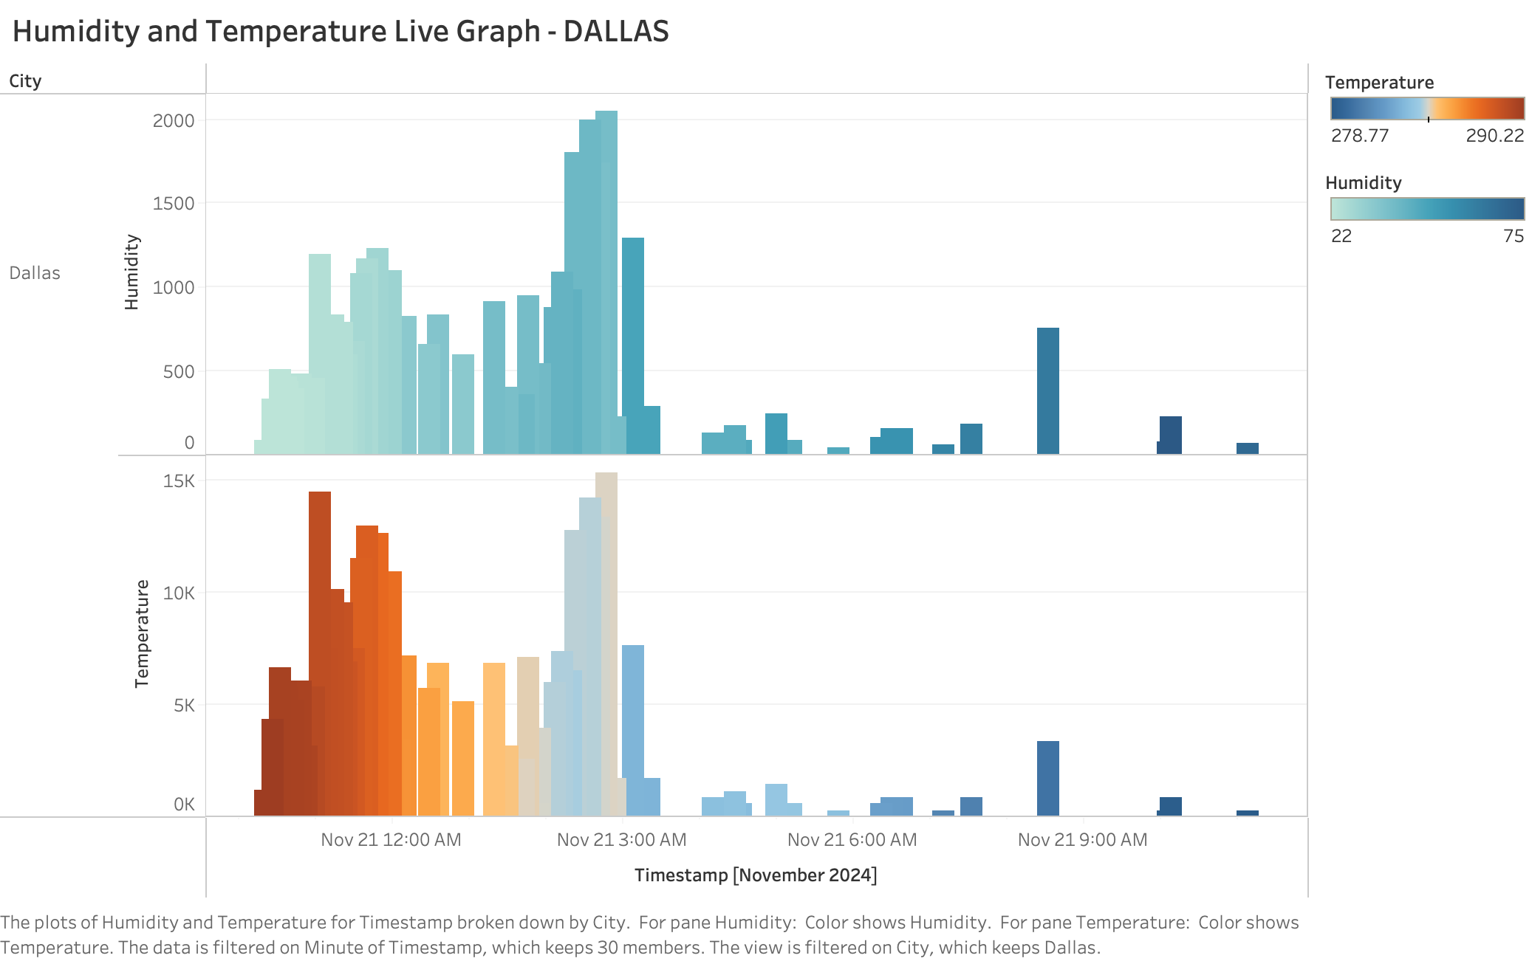

**The Pipeline:**

Created in Lucid Chart

